Horizontal case 1 – placing on the left

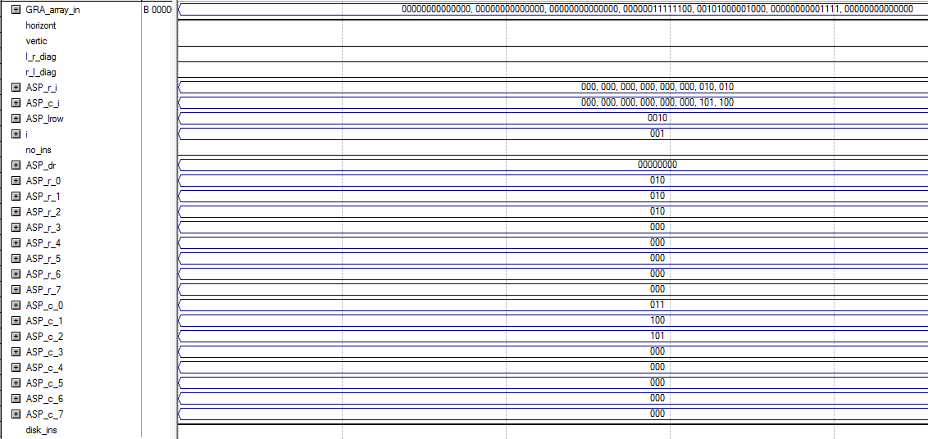

Horizontal case 2 – placing on the right

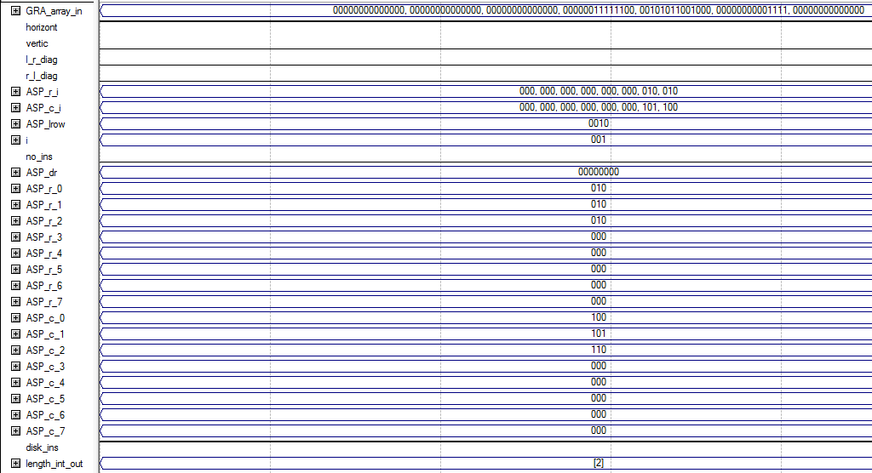

Vertical case 1 – placing below

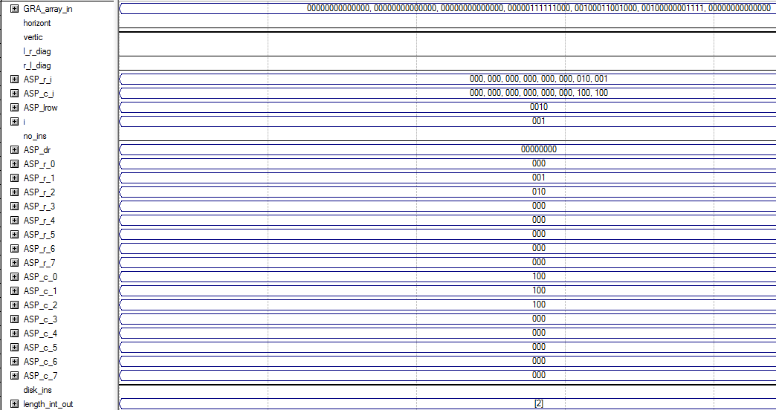

Vertical Case 2 – placing above

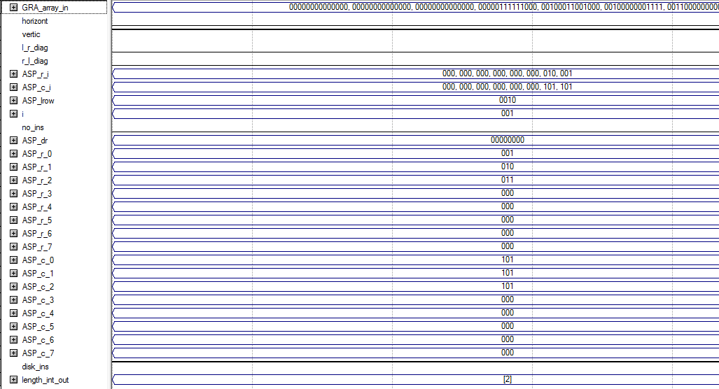

L-R Diagonal Case 1 – Placing down and right

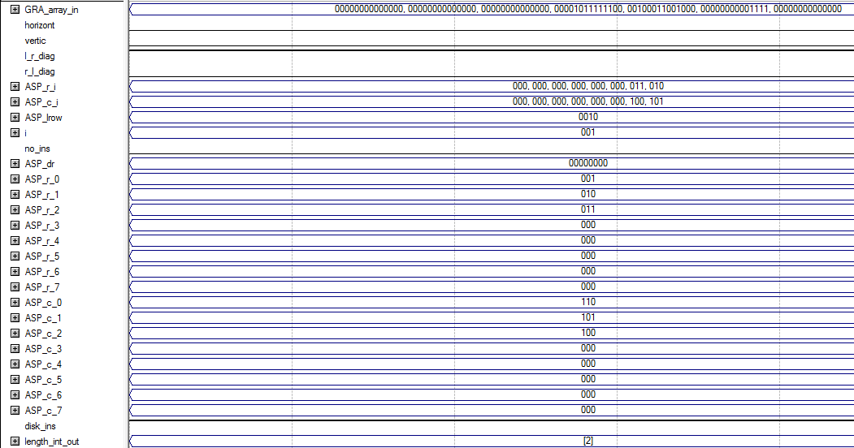

L-R Diagonal Case 2 – Placing up and left

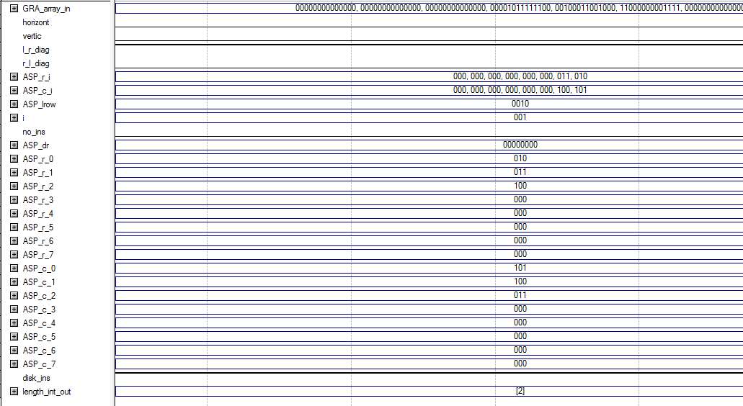

R-L Diagonal Case 1 – Placing down and left

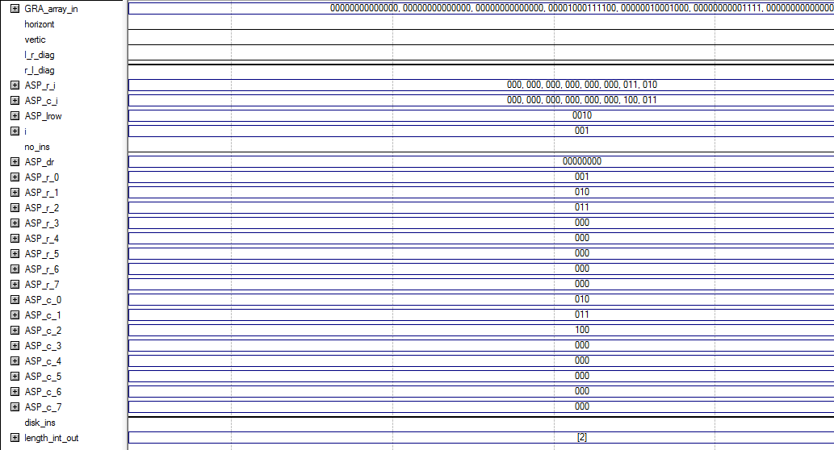

R-L Diagonal Case 2 – Placing up and right

